ALPHA Supply List for 2019-2020

Please bring the following supplies. These will be in addition to what your child’s homeroom teacher is requesting. You may bring these in on orientation day next year or during the first week of school. Please be sure to write your child’s name on the items that are in bold print. Those will not be shared.

Hint: Check Dollar Tree. A lot of this can be bought there for (you guessed it…) $1!

- Head Phones - they need some that stay in the ALPHA room.

- 1 vinyl folder with 3 prongs

- 1 vinyl folder with 3 holes

- 1 composition notebook

- Expo markers - a 4 pack or more

- 1 bottle of hand soap (NOT sanitizer - we have a ton of that already)

- Gallon, quart, and/or snack sized zip lock baggies (just one kind unless you feel like being generous)

- A bucket seat - see the back of this paper (or scroll down if viewing online) for more information

Optional

The following items are not required. However, most students prefer to have them. It makes them happy. All of these items will need to have the student’s name on them BEFORE bringing them to class. These will be kept in the bucket seats and will be for each child’s use only. Feel free to go ahead and put the items into the bucket before bringing it to school.

- Crayons
- Pre-sharpened colored pencils (we don’t have time to sharpen whole boxes of these at school)
- Hand-held pencil sharpeners (They CANNOT use my electric sharpener for colored pencils).
- Fancy pencils (I have plenty of pencils, but some kids love the fancy ones)
- Markers

Please do NOT bring glue or scissors. I have plenty.

Bucket Seats
Each child will need a bucket seat. These will be the only place where students can store their things without having to constantly carry them back and forth to their classroom. These buckets can be purchased at any Lowe’s or Home Depot for around $5 (lids are separate and cost around $2). Please read the rules below. Please feel free to donate an extra bucket if you choose to do so. If you cannot afford to purchase a bucket, please let me know.
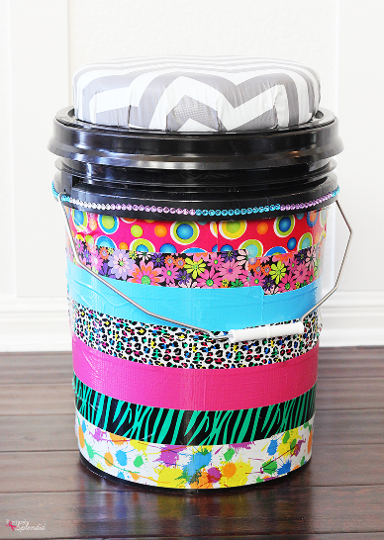
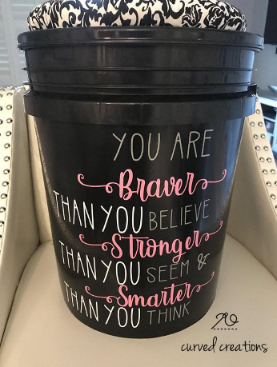

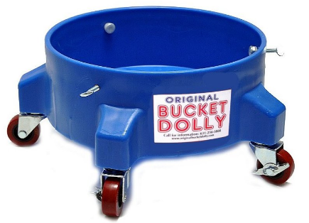

Bucket Rules:

1. Buckets must be round, 5 gallon buckets that are clean and do not smell of paint etc…
2. Buckets must be made at home.
3. They must have the student’s name somewhere on the outside.
4. I prefer that the seat NOT be padded, but it’s fine if you want a cushion.
5. Decorations and themes must be appropriate.
6. I prefer you leave the handles attached if possible.
7. They do make rollers for bucket seats. If you want to do that, it’s fine with me. However, I reserve
the right to remove the wheels if needed.

Instructions for making seats available at the following links:
https://www.youtube.com/watch?v=QjFw8L32_R8 https://www.youtube.com/watch?v=78wTTtZ67qk

Bucket Tips:

- Duct tape works better than paint.
- If you paint it, use polyurethane or something like that to keep it from chipping. Even if you used paint made for plastic.
- Vinyl stickers work pretty well.
- Sharpie markers work pretty well.
- Hot glue will only hold things on for so long before they fall off.
- If you want a ready made one, they have them at academy and places of that sort.
- Don’t spend a ton of money. Your children will bring them home each summer and you may end up redesigning them each year (up to you).

